**EXP NO 2: CREATE A SIMPLE CLOUD SOFTWARE APPLICATION FOR FLIGHT RESERVATION SYSTEM USING ANY CLOUD SERVICE PROVIDER TO DEMONSTRATE SAAS**.

**DATE:**

**AIM:**

To create a simple cloud software application for flight reservation system using any cloud service provider to demonstrate saas.

**PROCEDURE:   
step1:** Go to zoho.com.  
 **step 2:** Log into the zoho.com.   
**step 3:** Select one application step.

**step4:** Enter application name as flight reservation system.  
 **step 5:** Created new application flight reservation system.

**step 6:** Select one form   
 **step 7:** The software has been created.

**IMPLEMENTATION:**

**STEP1: GOTO ZOHO.COM**

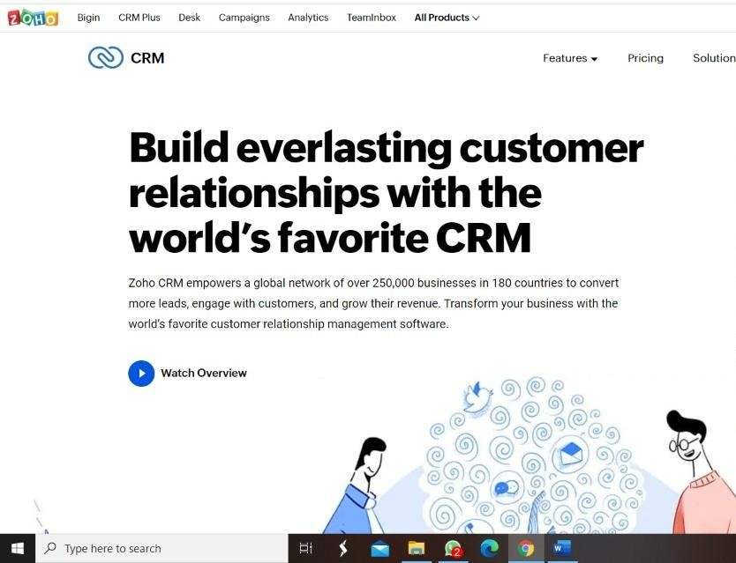

**STEP 2: LOGINTOTHE ZOHO.COM**

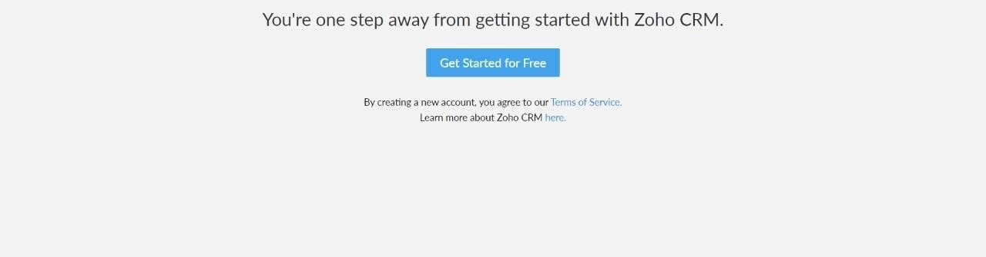

**STEP 3: SELECT ONE APPLICATION**

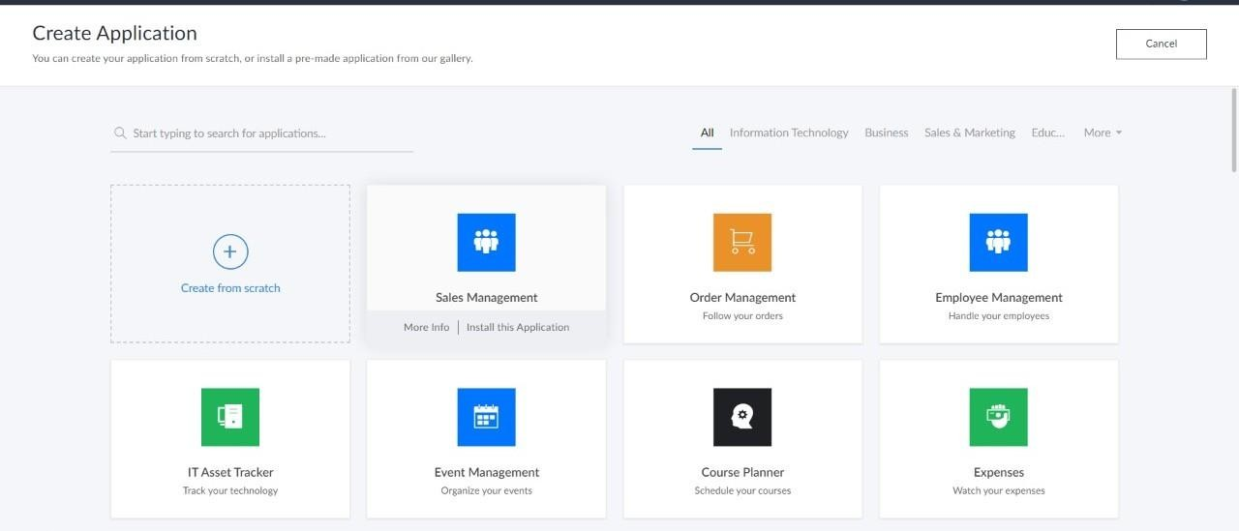

**STEP 4: ENTER APPLICATION NAME**

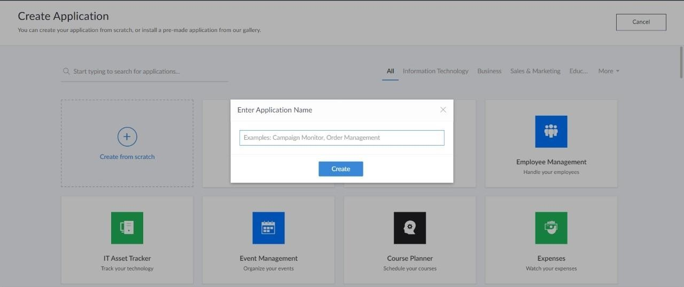

**STEP 5: CREATED NEW APPLICATION**

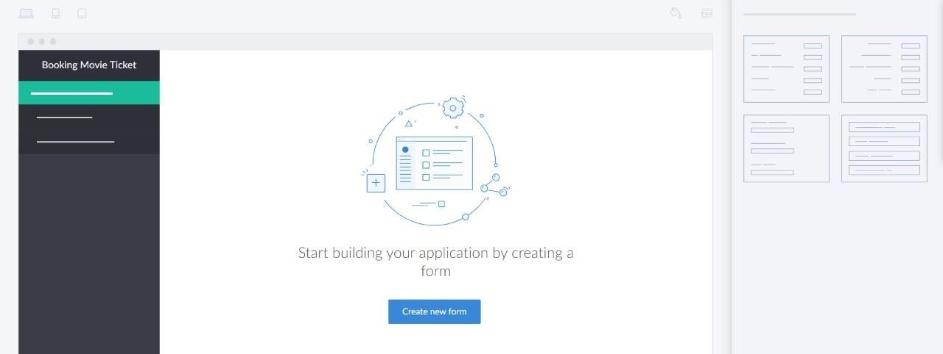

**STEP 6: SELECT ONE FORM**

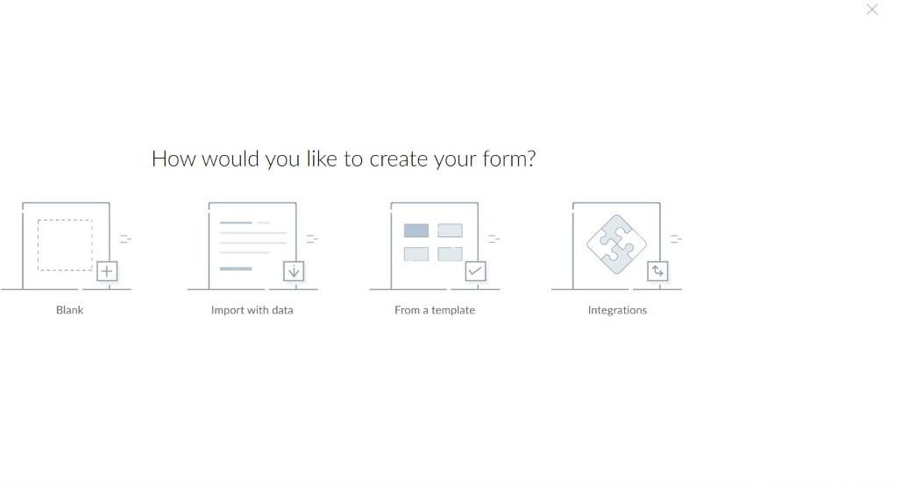

**STEP 7: THE SOFTWARE HASE BEEN CREATED.**

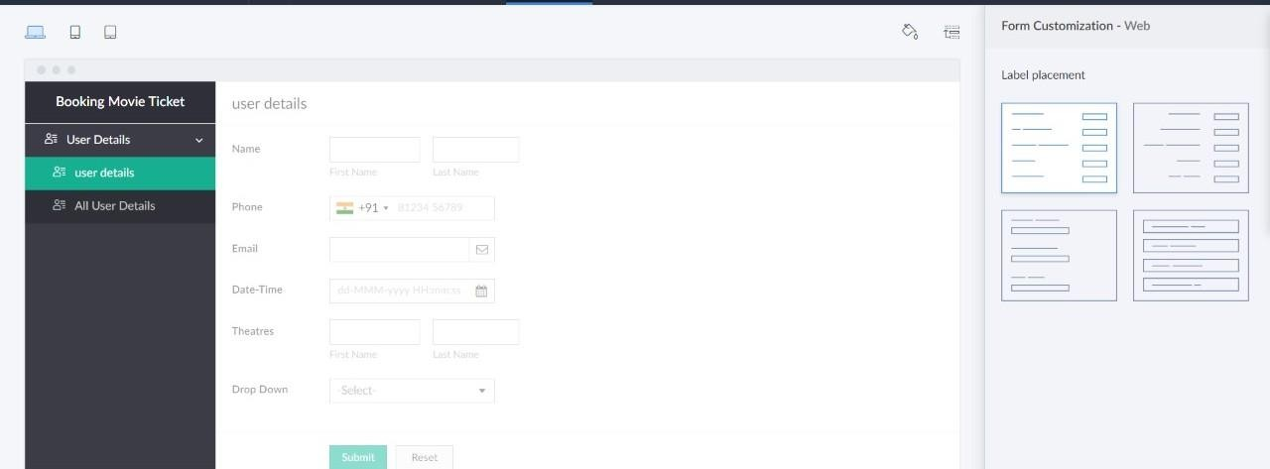

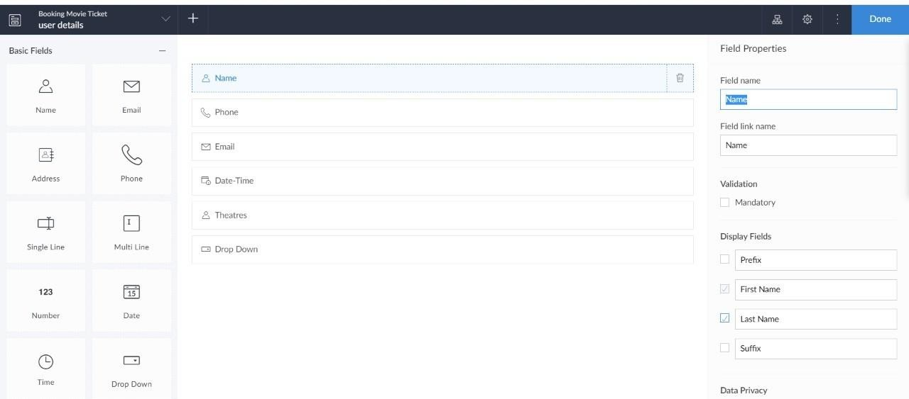

Sample output:

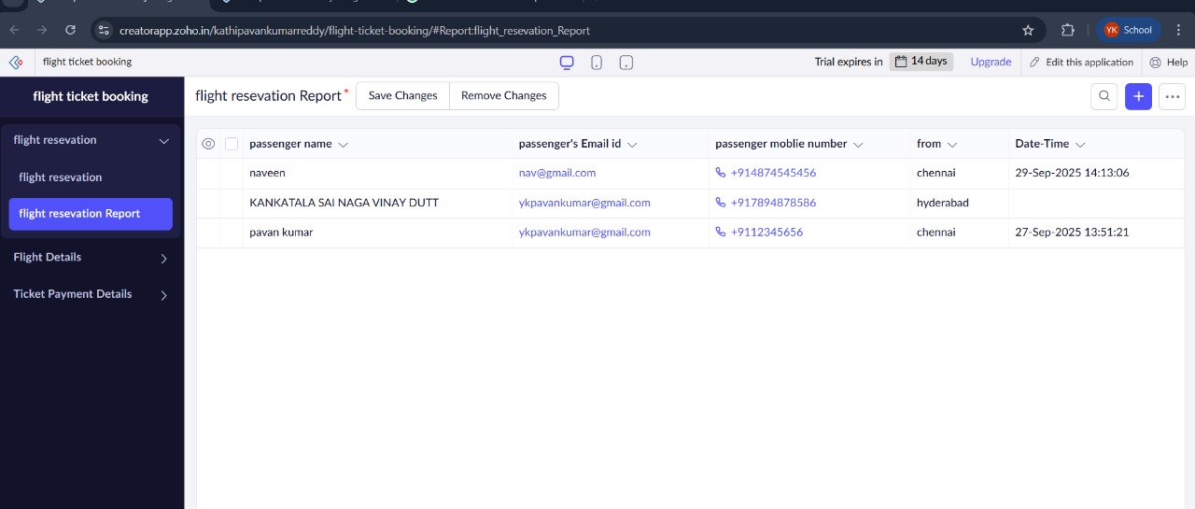Passengers details:

Flight Details:

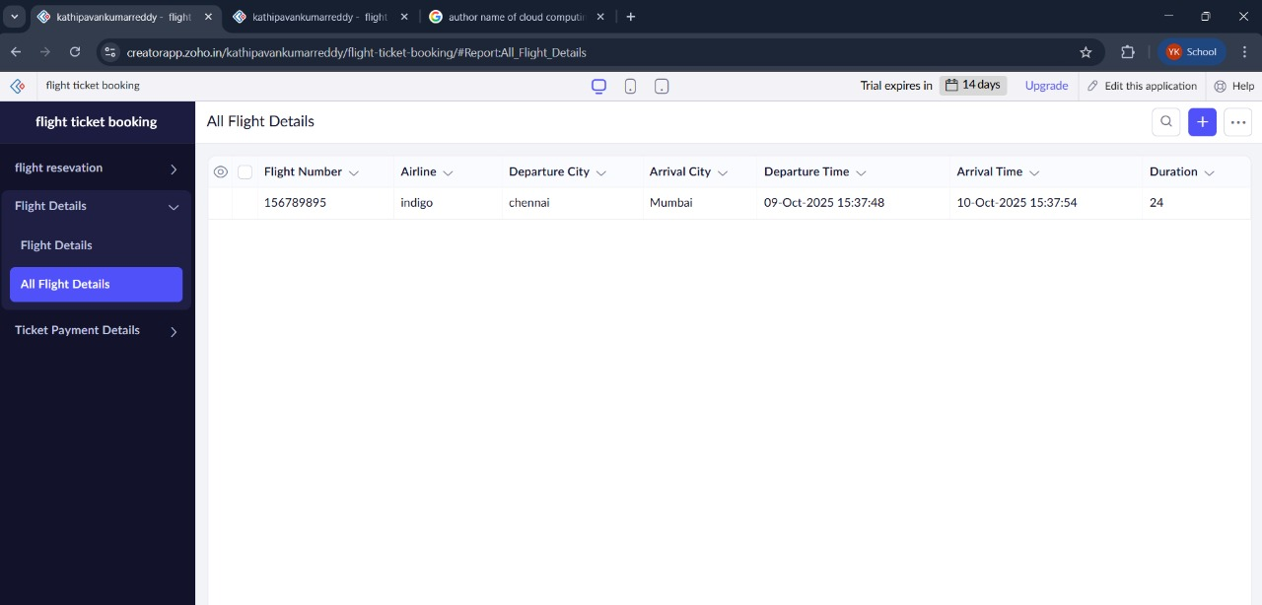

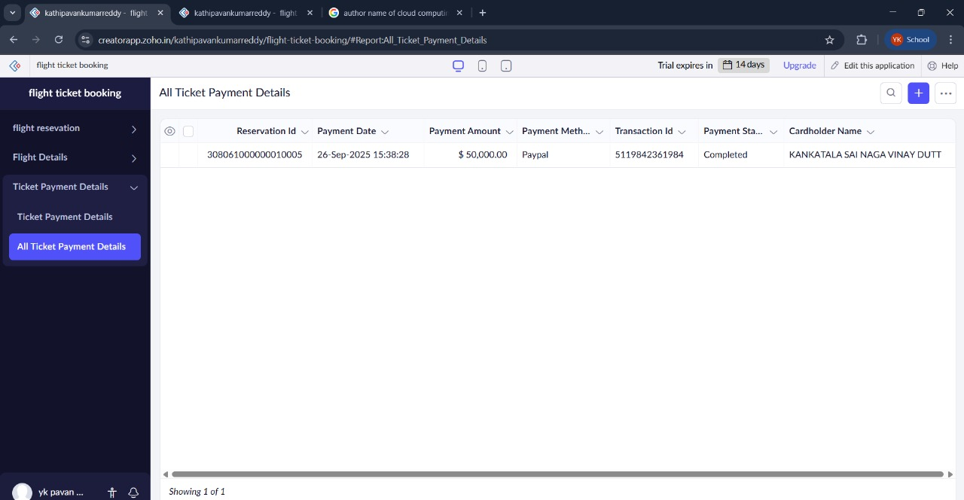Payment Details: